# RECIPE SHARING PLATFORM

### A MINI PROJECT REPORT

#### Submitted by

#### Group: G34

**Simar , 2410993399,**

**Satyam Chabra, 2410993396,**

**Dhawal Goyal, 2410993333,**

#### in partial fulfillment for the award of the degree of

## BACHELEOR OF ENGINEERING

***in***

CSE-AI



**CHITKARA UNIVERSITY**

**CHANDIGARH-PATIALA NATIONAL HIGHWAY**

**RAJPURA (PATIALA) PUNJAB-140401 (INDIA)**

##### September,2024

**TABLE OF CONTENTS**

|  |  |  |
| --- | --- | --- |
| Sr.no | Section | Page no |
| 1 | Introduction |  |
| 2 | Problem Statement |  |
| 3 | Technical Details |  |
| 4 | Key Features |  |
| 5 | Project Highlights |  |
| 6 | Bonus feature |  |
| 7 | Conclusion |  |
| 8 | References / Links Used |  |

1. **Introduction**
   1. **Overview**

The recipe-sharing website is designed to bring food enthusiasts together by providing a platform to share and discover recipes. Users can create accounts, submit their favorite recipes, and explore a wide variety of dishes from different cuisines. The website aims to foster a community where users can interact, share feedback, and find culinary inspiration

1. **Problem Statement**
   1. **Recipe Sources**

**Dispersed over multiple websites, blogs, and social media platforms, many individuals find it difficult to locate trustworthy and varied recipes . It is challenging to find and effectively arrange recipes because of this fragmentation.**

* 1. **Lack of Personalisation**

**Current platforms frequently fall short in offering tailored advice based on unique dietary requirements, tastes, and culinary prowess . Meal preparation and planning may become less fun and more labour intensive as a result.**

* 1. **Community Engagement**

**To facilitate the sharing of culinary experiences, feedback, and mutual learning, a more engaged and encouraging community is required . Strong community features that encourage participation and interaction are frequently absent from current platforms.**

**3.Technical Details**

**3.1 Technologies Used**

**3.1.1 HTML**

HTML (Hypertext Markup Language) is a text-based approach to describing how content contained within an HTML file is structured.

This markup tells a web browser how to display text, images and other forms of multimedia on a webpage**.**

**3.1.2 CSS**

CSS (Cascading Style Sheets) is a language designed to simplify the process of making web pages

presentable. CSS provides developers and designers with powerful control over the presentation of HTML elements.

**3.1.3 Responsive Design**

We implemented a responsive design approach, ensuring that the Website adapts seamlessly to different screen sizes (desktops, tablets, and smartphones). This is crucial for providing a consistent user experience across devices.

1. **Key Features**
   1. **User Registration and Profiles: Users can create accounts, personalize their profiles, and connect with other food enthusiasts.**
   2. **Recipe Submission and Management: A user-friendly interface for submitting recipes, including details like ingredients, preparation steps, and cooking times.**
   3. **Search and Filtering: Robust search functionality allowing users to find recipes based on keywords, ingredients, cuisine types, and dietary restrictions**.
   4. **User Interaction: Features enabling users to like, comment, and bookmark recipes, fostering engagement and community building.**
   5. **Nutritional Information: Displaying nutritional details for each recipe to help users make informed choices.**
   6. **Step-by-Step Cooking Instructions: Detailed instructions with images or videos to guide users through the cooking process.**
   7. **Recipe Ratings and Reviews: Users can rate and review recipes, helping others to find the best dishes.**

**4.Project Highlights**

The following images are some of the project highlights:

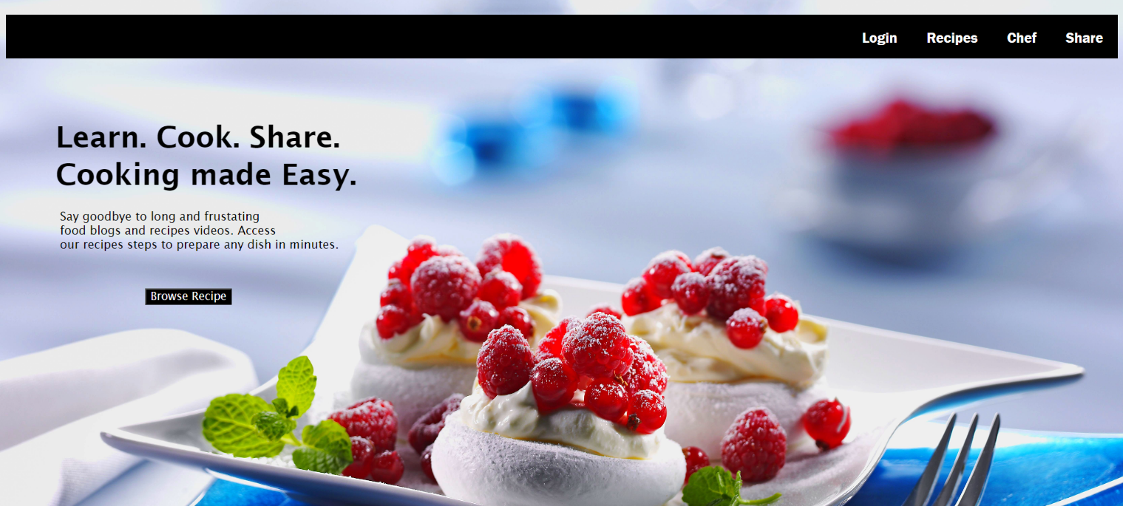

HTML

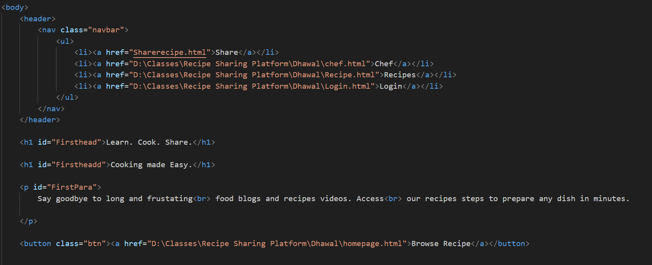

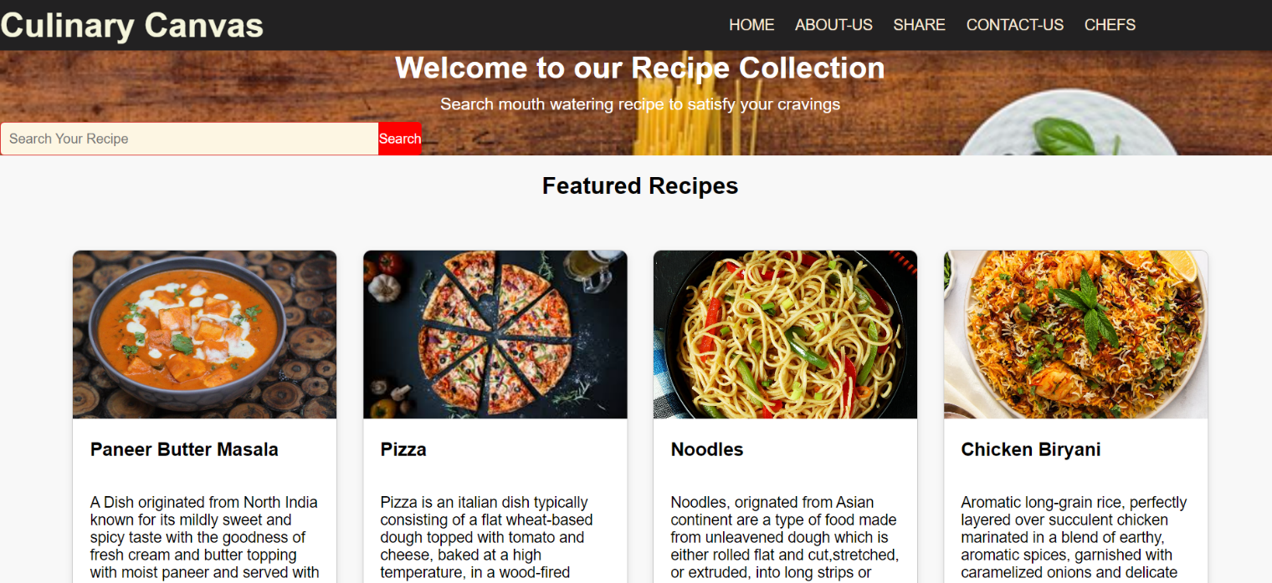

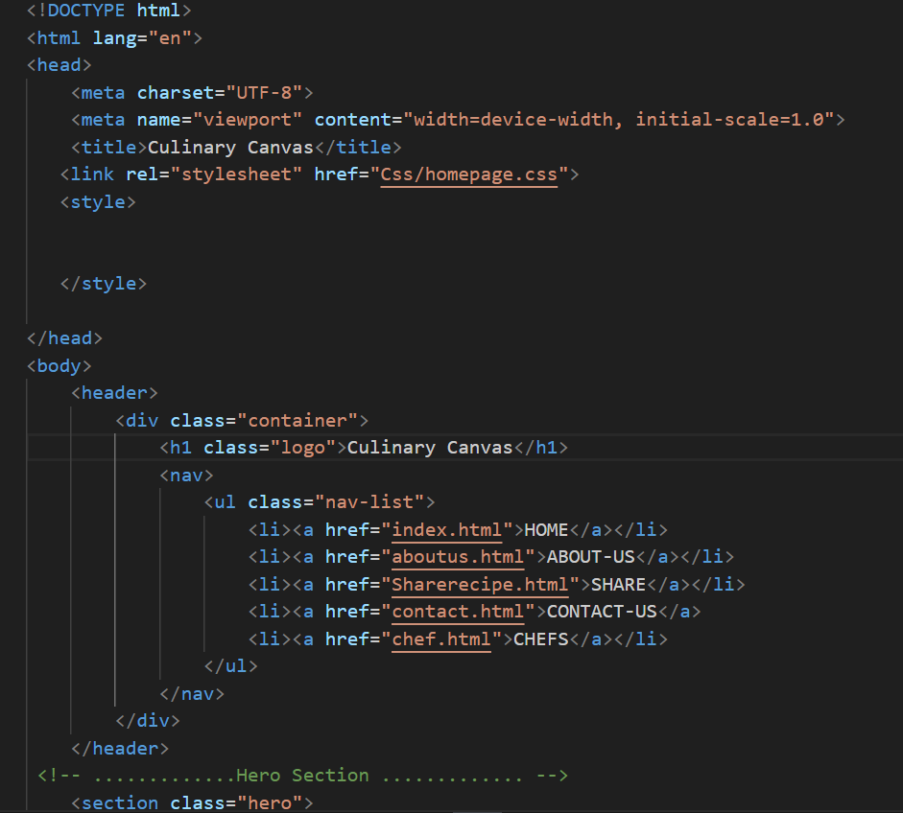

**5.Bonus Highlights**

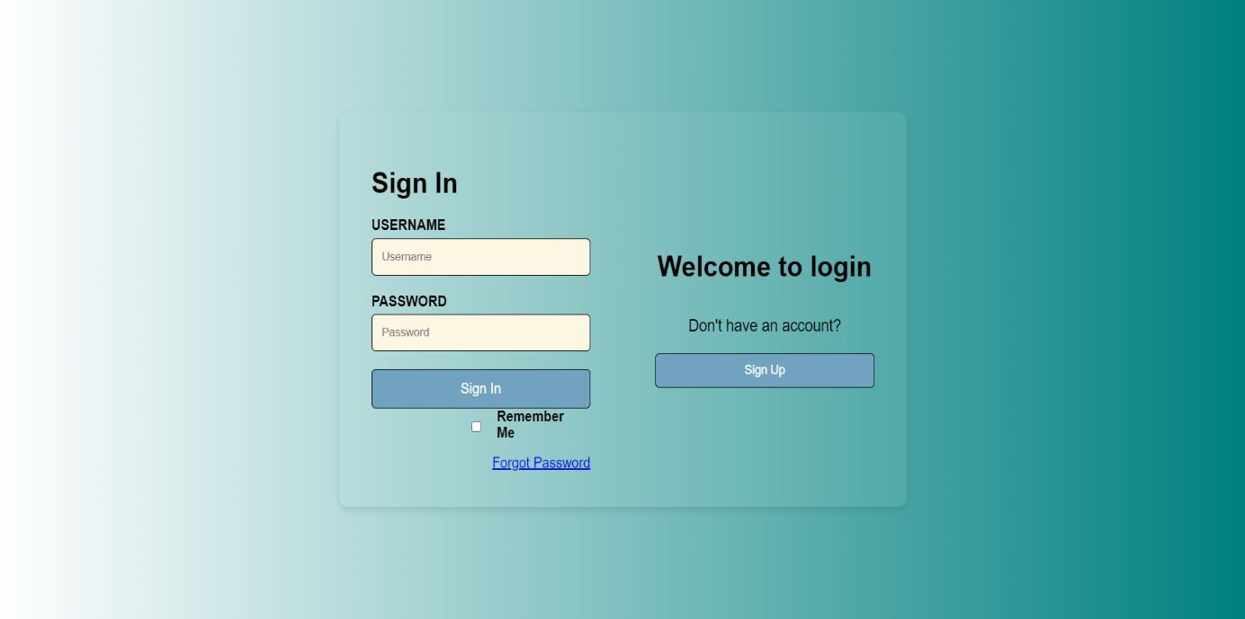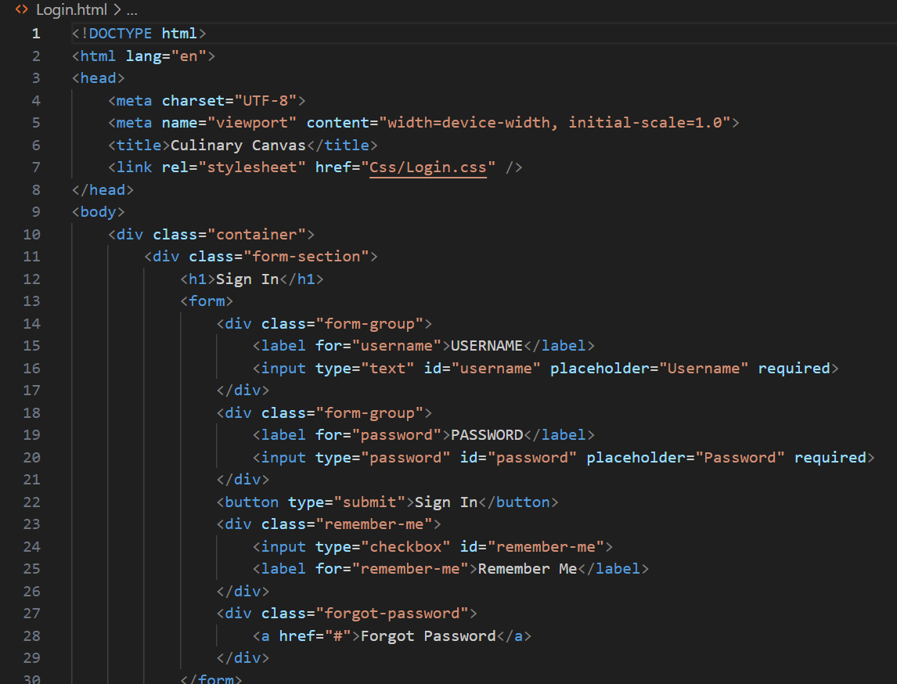

**6.Conclusion**

**Our recipe-sharing website project successfully addresses the need for a centralized and engaging platform for food enthusiasts. By leveraging modern technologies we have created a dynamic space where users can share and discover diverse recipes, interact with a supportive community, and enjoy a culinary experience.**

**6.1 Our Experience**

Building the Recipe sharing platform project was a valuable experience that helped our team develop a deeper understanding of database management and user interface design. This project not only enhanced our technical skills but also gave us insight into how to create a user-friendly workspace. Additionally, it fostered collaboration and problem-solving skills within our team, and provided a practical application of theoretical knowledge.

**7.References/Links Used**

**References used by us to solve the problems while creating the address book:**

* MDN Docs (“[Click here](https://developer.mozilla.org/en-US/)”)
* W3 Schools (“[Click here](https://www.w3schools.com/)”)
* You Tube (“[Click here](https://www.youtube.com/)”)